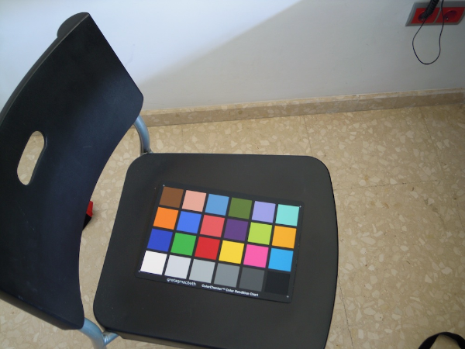 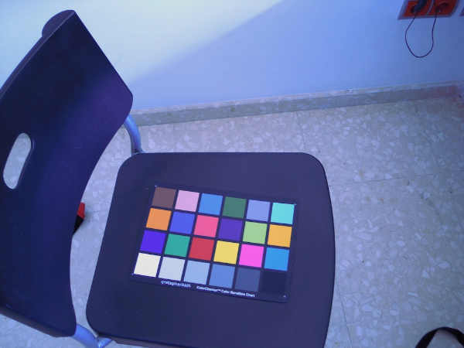

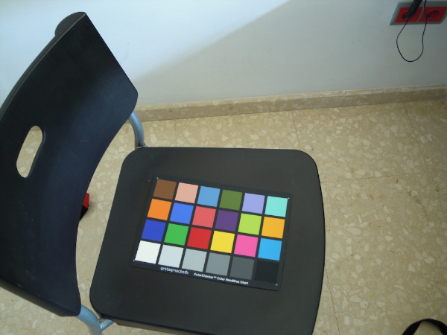 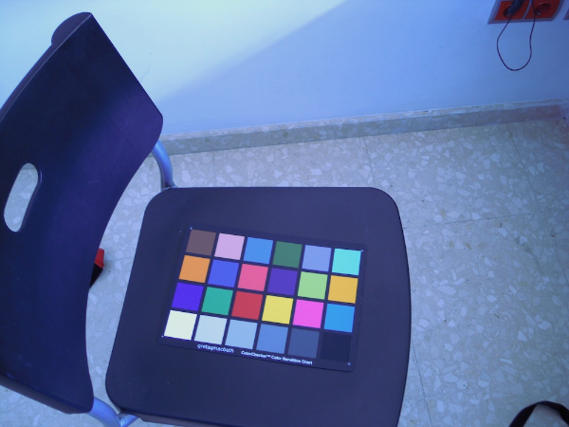

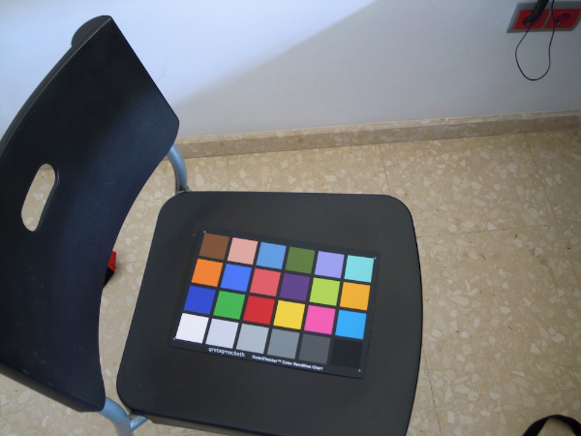 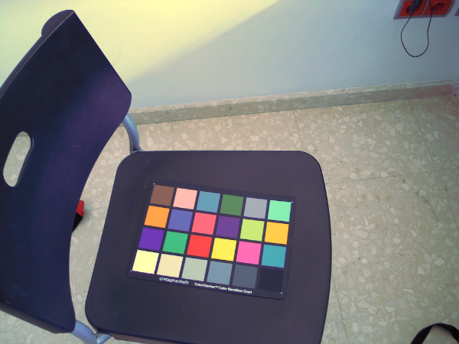

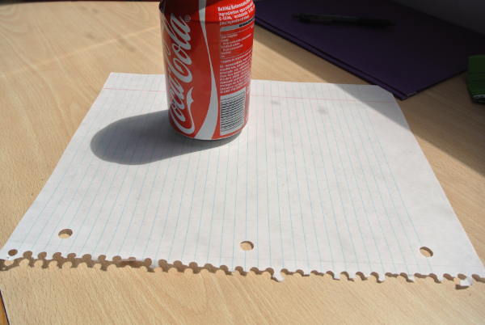 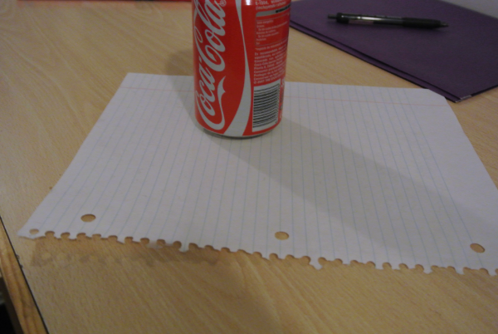

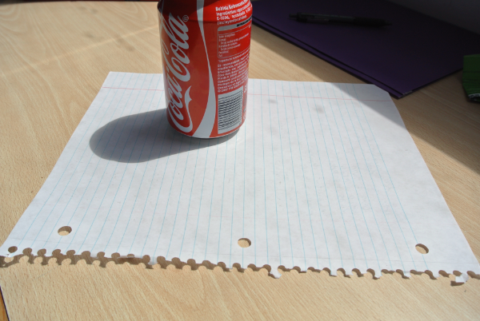 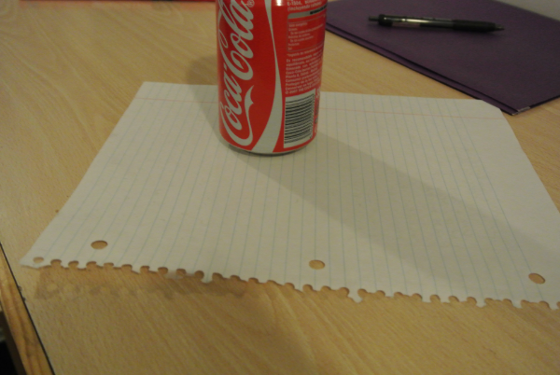

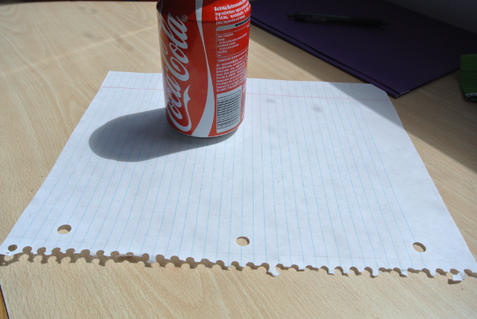 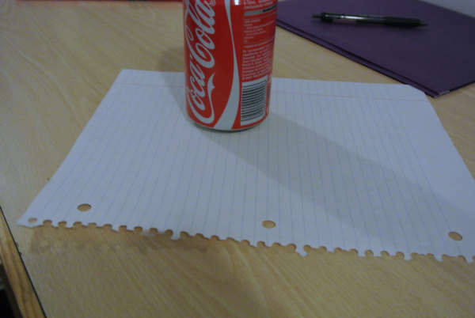

1. To me, the technique that worked best would be the “Gray World” Method, because of the three methods it was able to obtain the “whitest” image.
2. The goal of white balancing is to determine the color in the image that can be designated as “white”. Thus, my biggest criteria when judging the images was to find which image had the most color that could be considered “absolute white” (aka RGB values are all zero). This was determined mainly by simply examining it to the best of my natural ability.
3. For the “Gray World” Method, there were noticeable differences between the default image and the corrected image. For the daylight-based images, the corrected image did appear to be just slightly bright than the original. For the other two images, there was enough discoloration that the emphasis on white in the corrected images was very notable.